PUMP PERFORMANCE

Total Dynamic Head

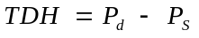
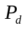 = discharge pressure
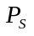 = suction pressure

Hydraulic Horsepower

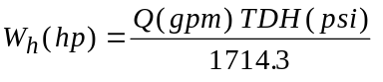

Shaft Efficiency
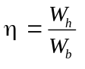
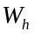 = theoretical required power (hp)
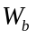 = actual shaft work or brake-horsepower
note 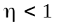 because there are friction losses inside the pump.

Available Net Positive Suction Head

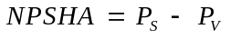
= suction pressure
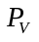 = vapor pressure of fluid

NPSHA has to be positive. Otherwise, the fluid enters the pump with bubbles.

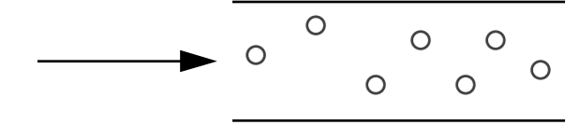

As pressure increases inside the pump the bubbles collapse.

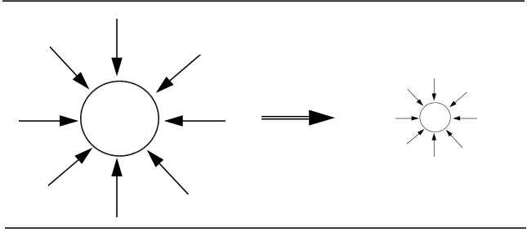
This phenomena is called CAVITATION and it

-Reduces capacity
-Damages the pump

Net Required Positive Suction Head (NPHSR)

Ideal pumps will not cavitate if NPHSA is positive.

However a small pressure decrease can take place in a pump due to internal losses close to the suction.

====> if NPSHA = 0 bubbles can form and cavitation takes place.

====> NPSHA is a required value suggested by the manufacturer

SPECIFICATION CRITERIA

NPHSA > NPHSR
Head Capacity Curves
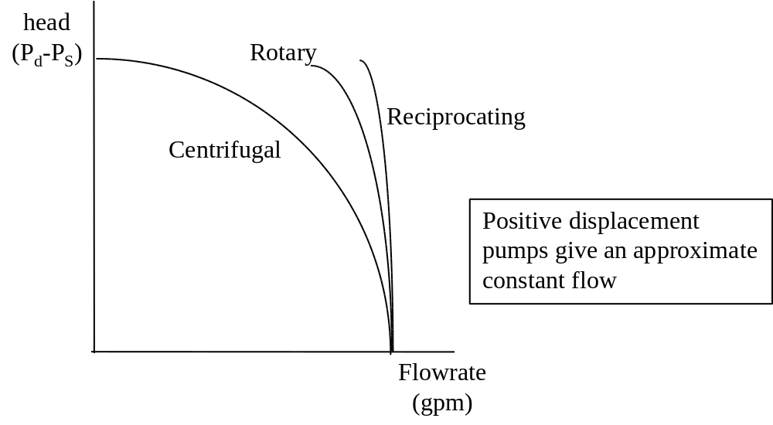
Thus, centrifugal pumps are chosen because

They can operate in a wider range of flowrates which is good for control and process flexibility.
---------------------------------------------------------------------------------------------------------
If you are stuck with a positive displacement pump, the following diagram shows how you can regulate flow.
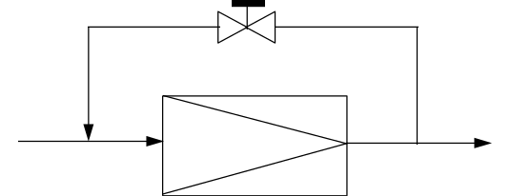

However, this arrangement will:
- use more energy
- heat up fluid
Centrifugal Pump Performance Curves

(Fixed speed, rpm)
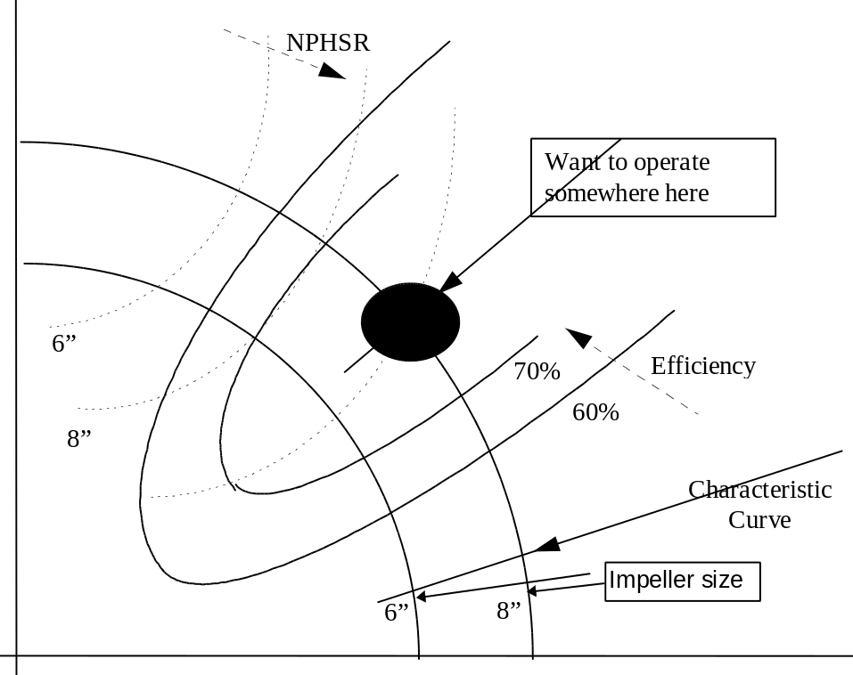

Specifying A Pump
1) Need 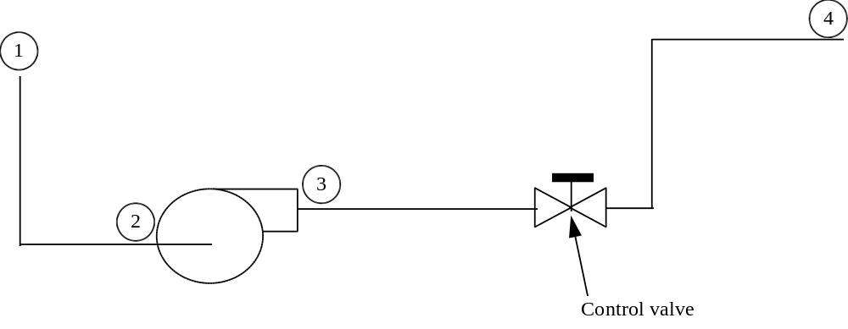
System head H₅ = (P₄-P₃)+(P₂-P₁)
Pump head Hp

But Hp = Hs

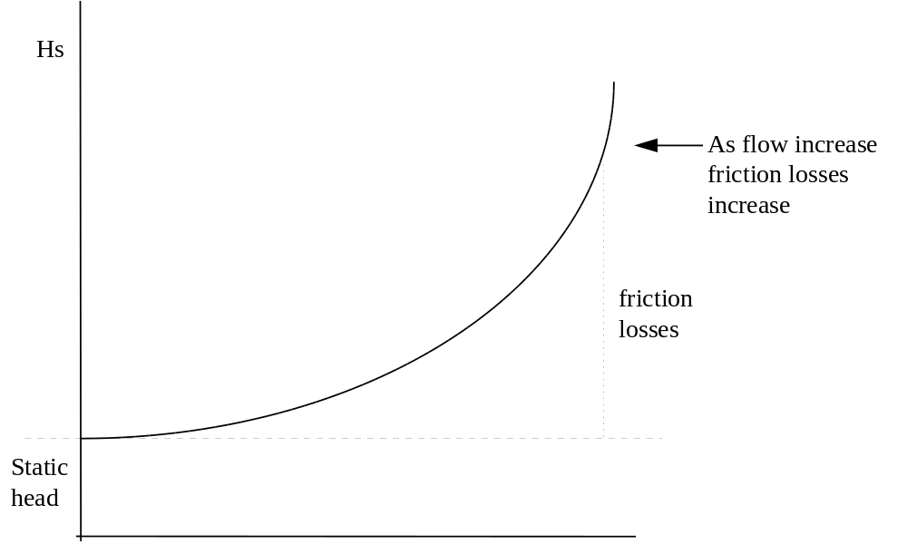
Effect of a throttling valve
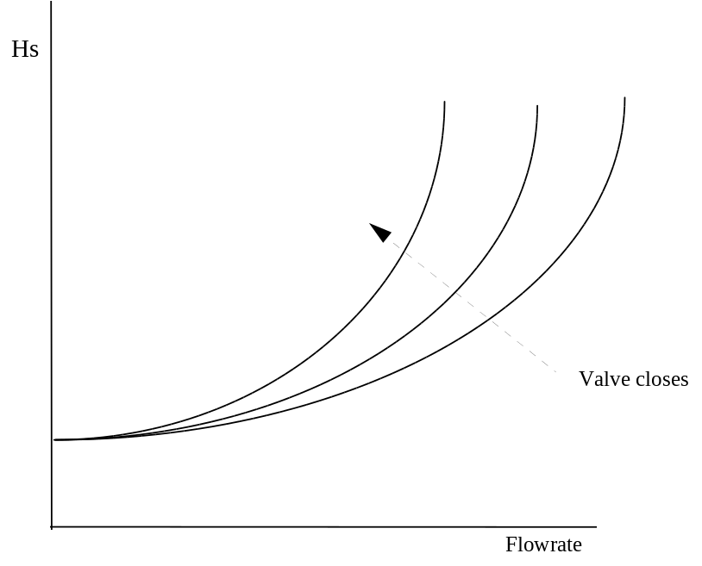

Since Hs = Hp , pick the Hs curve close to 80% open, at maximum flow

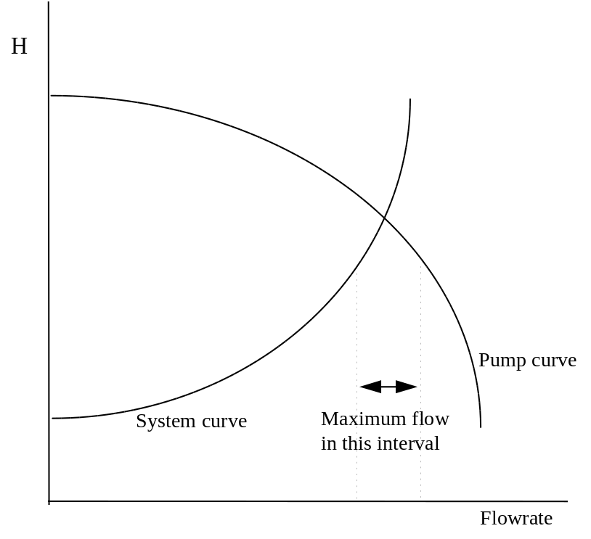
Parameters you can control when selecting the pump
- impeller diameter
- speed (not very common)
- the model

Things to look for
- Maximum efficiency
- NPHSA > NPHSR

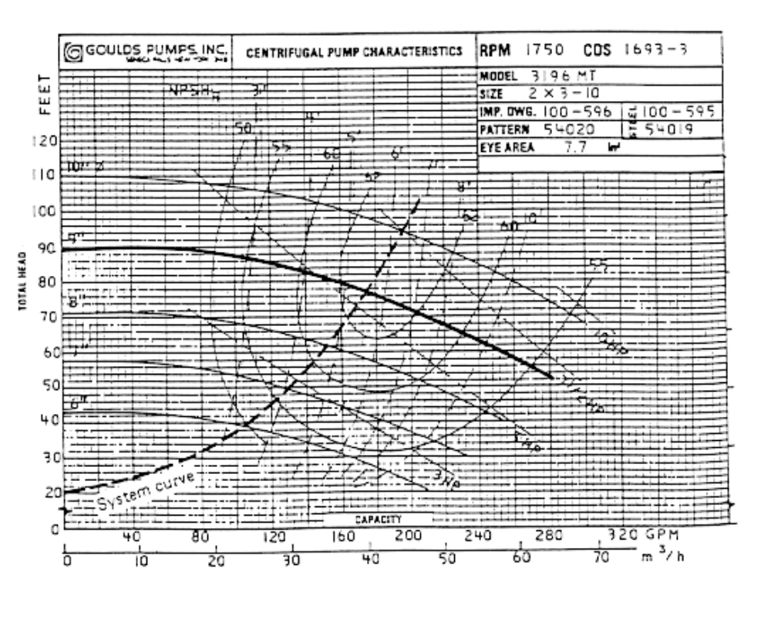
What to do if NPHSA is too low

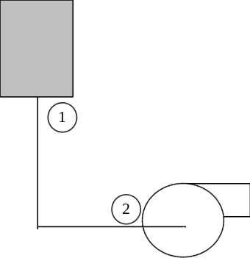
NPHSA = P₂-P_{V}

Increase P₂ !!! (How?)
Increase Z₁
This is the reason why pumping fluids that are close to saturated conditions require that the vessel upstream be elevated. Flash tanks are typical examples of this.
Control Valves
(see Chem. Eng., April 1978, October, 1971)

Valve characteristics

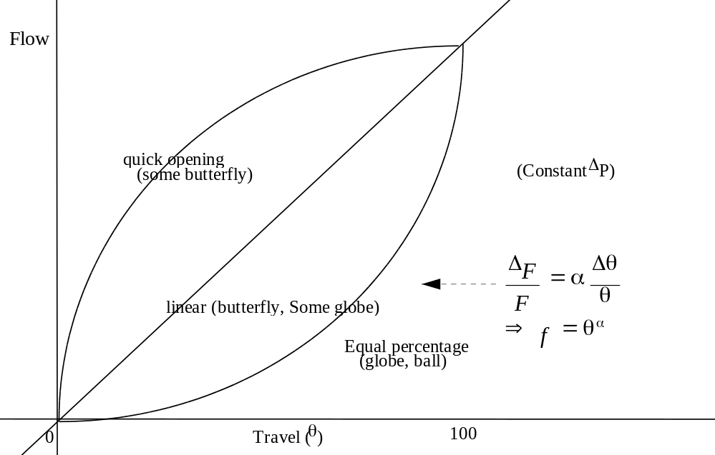
Valve flow Coefficient (C_{v})
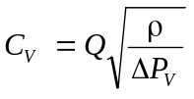
Q = flowrate (gpm)
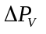 = Pressure drop (psi)
ρ = Specific gravity of fluid
How is C_{v} measured ?
Measure the flowrate of water at 60 ºF where
* ΔP = 1 psi
* valve is totally open

How does the valve behave within a system ?
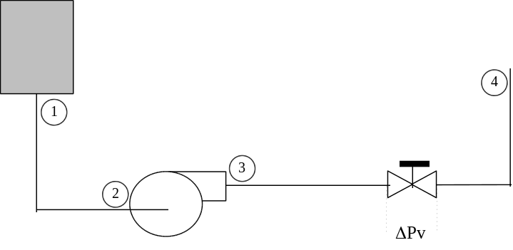
Let ΔP₁ = P₂ - P₁
ΔP₂ = (P₄-P₃) - ΔP_{V}
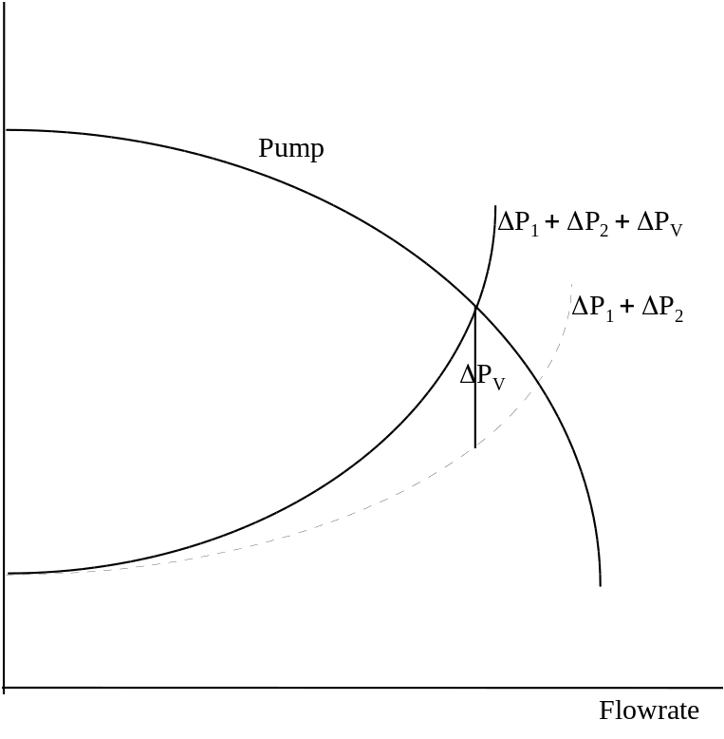
Valve Pressure Drop Ratio
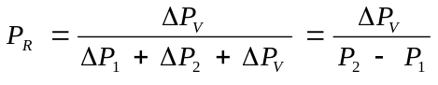
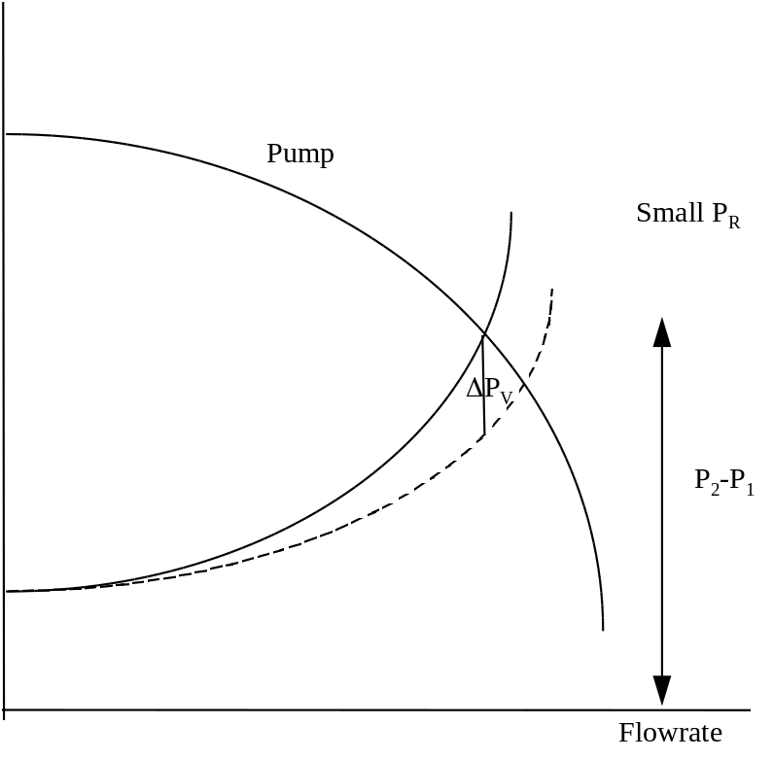
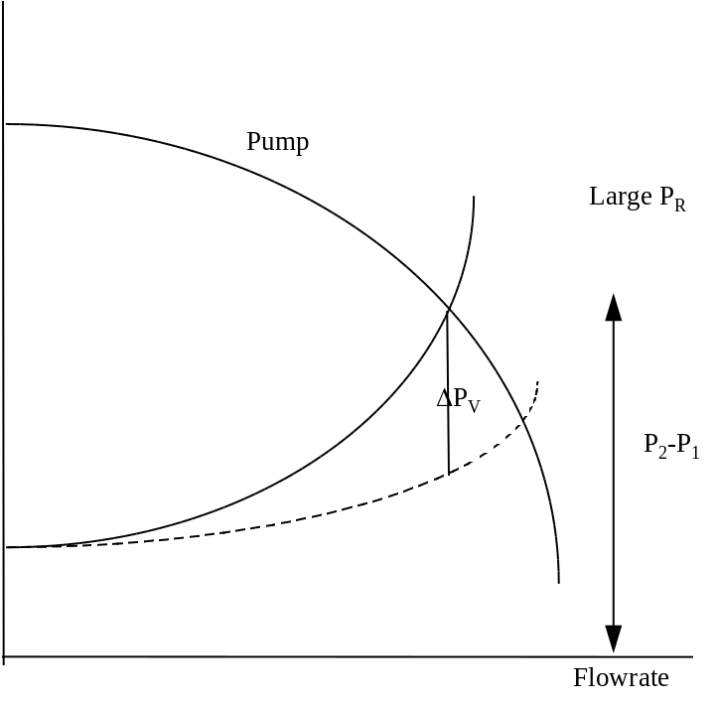
Effect of valve travel

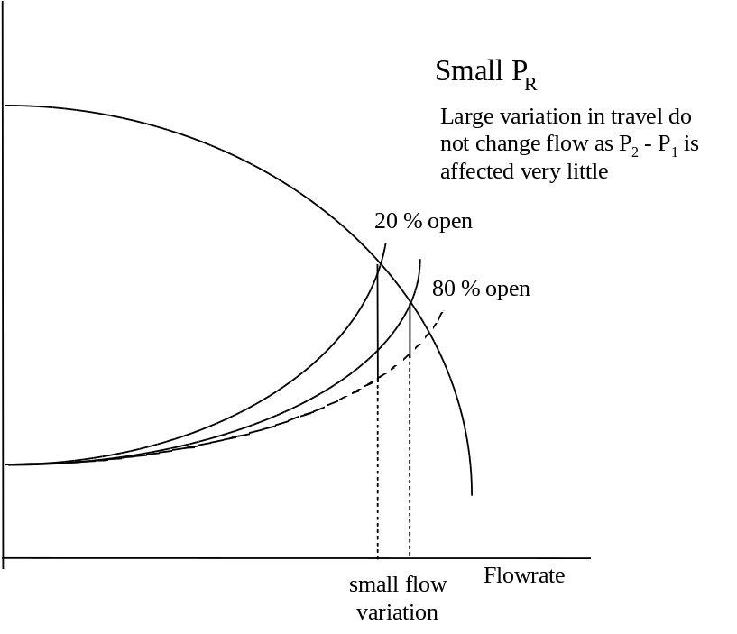
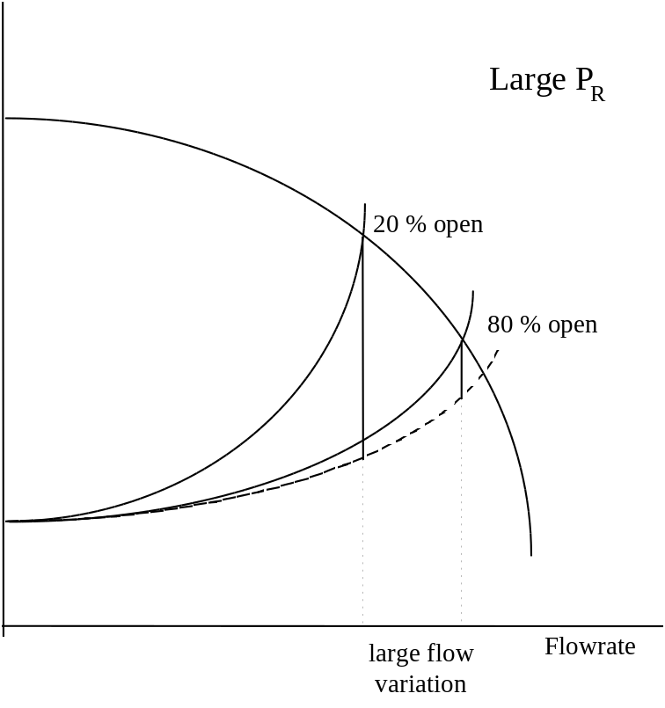
Installed Characteristics
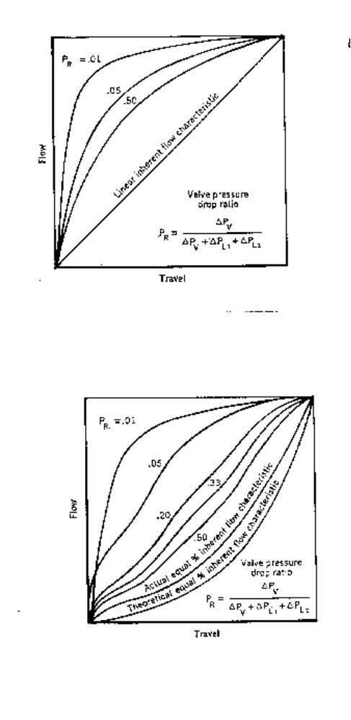
Valve Specification
Need to give
- C_{V}
- Characteristics

HOW TO OBTAIN C_{V}
C_{V} is obtained from flowrate, sp. gr. and ΔP_{V} at maximum flowrate conditions.

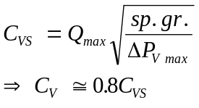

Now look for a valve that has this C_{v}

Characteristics.
Want linear response when installed since the stem moves linearly with signal coming from controller.
*Large flowrate variation expected
====> Pick equal % valve with P_{R} ≅ 0 at maximum flow conditions.
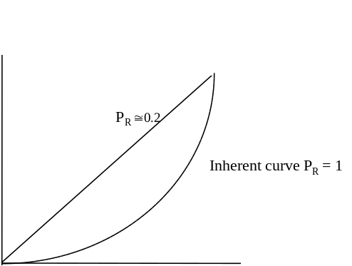

*Low flowrate variations can pick equal % or linear
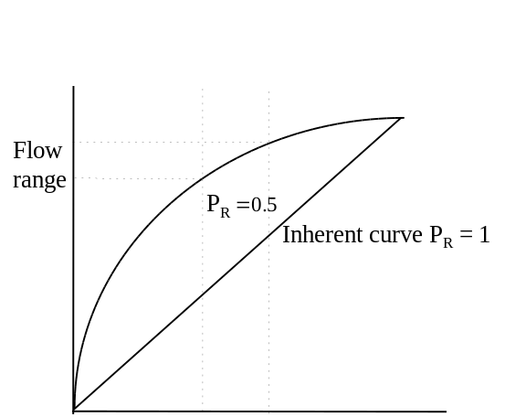
Linear is preferred when pump curve is flat.
OPTIMAL PIPE DIAMETER
(P&T ch. 11)
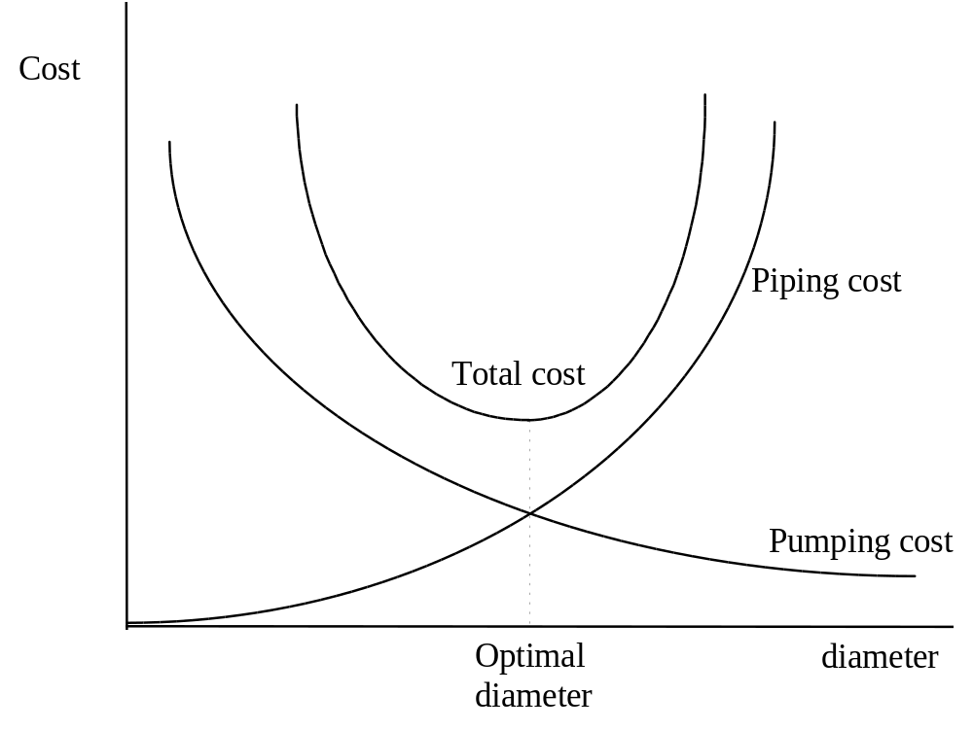
Pumping cost = Annualized cost of pump + Cost of electrcity
Piping costs = C(diameter)^{n}
(includes fittings)
Optimal piping + Pump arrangement

Since Isometric is fixed, then pipe length is fixed and Le (equivalent legth due to fittings and valves) is fixed

Pumping Costs

C_{E} = KW_{R} = KW/η
η = pump efficiency

Recall that
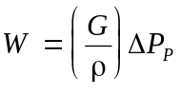
ΔP_{p} = Discharge pressure - Suction pressure
G = Mass flowrate
But
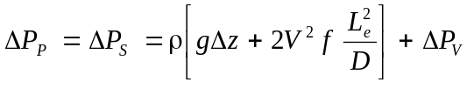
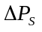 = System pressure drop
= Valve pressure drop

Assume that 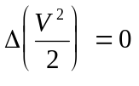 ( ==> ρ does not change and suction piping has same diameter as discharge piping.)

Now
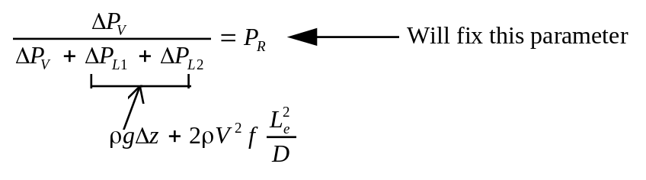
Then :
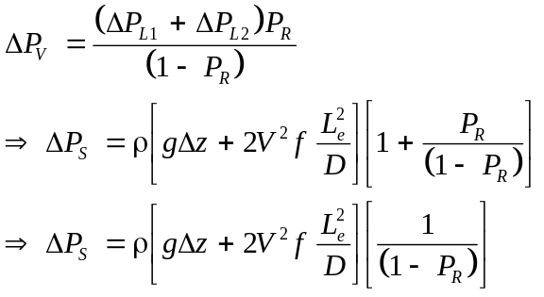
Put all together
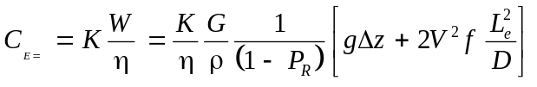

This is slightly different from P&T, where P_{R} is not considered

use 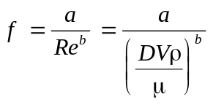
but
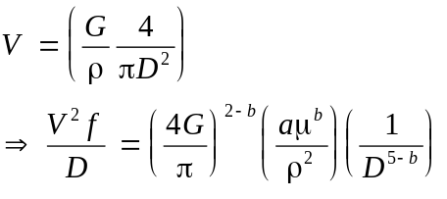

In this way, we have C_{E} as a function of D only!!!!!

Fixed Charges
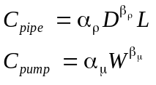
Total cost
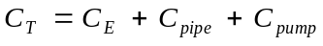

We have to find the minimum of the above total cost funtion. Options are:

1) Calculate for different diameters and determine the lowest one.
2) Use excel solver.
3) In provision, use strategy outlined in 1) in a calculator.

CAVITATION
Cavitation takes place when pressure inside the valve drops below vapor pressure of fluid.
How can that happen ?
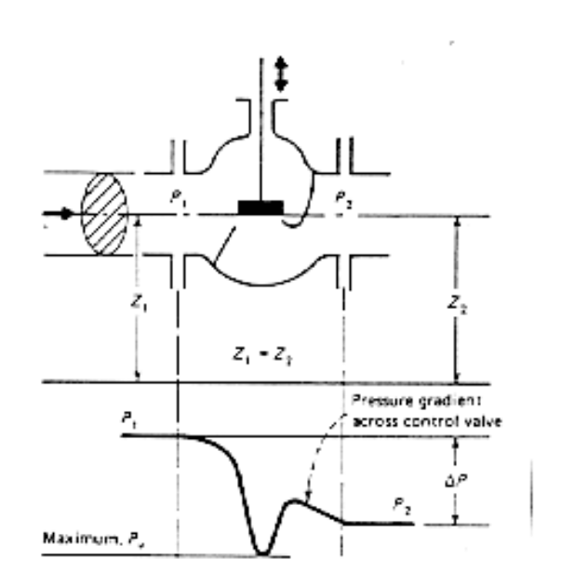

Pressure gradient across the valve

Criteria to determine possible cavitation
If 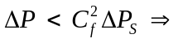no cavitation
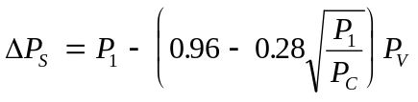
P_{V} = Vapor pressure
P_{C} = Critical pressure

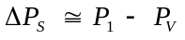 (for P_{V} < 0.5 P₁)
C_{f} = 0.98 equal % flow to open (against stem)
C_{f} = 0.85 equal % flow to close
Sizing Pressure Relief Valves
(Chem. Eng, Feb 1977)
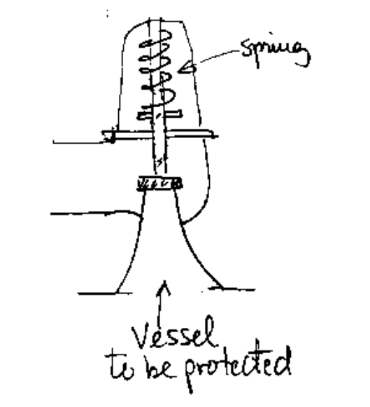

Spring settings
Overpressure for fully open valve
P_{F} = 1.25 P_{S}
Set pressure = P_{S} = 1.1 P_{M} (valve starts to open)
Max. Normal operating pressure = P_{M}

Sizing : Need to determine the flowrate at overpressure. This is related to how fast you want pressure to go down. Once the flowrate at overpressure is known you specify the area of the orifice

Let Q_{F} = flowrate at overpressure
for liquids use bernoulli equation with density (ρ) constant
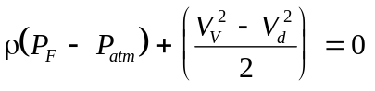
Velocity in Vessel (V_{V}) ≈ 0

Q = V_{d}A
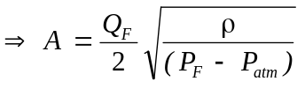

How to determine Q?
Liquid is in the vessel and will have to release some liquid to reduce pressure.

Recall from Thermodynamics that
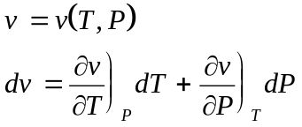
But β = volume expansivity
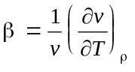
K = isothermal compressibility
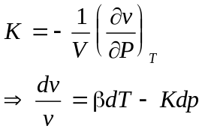
In a valve
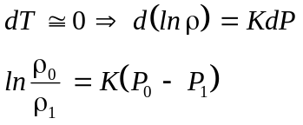
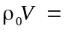initial mass
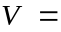 Volume of vessel

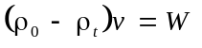
W = mass to release
But 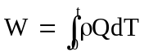
assume Q(t) = Q_{F}
W = ρ_{t}Q_{F}t

t = time in which you want pressure to go down
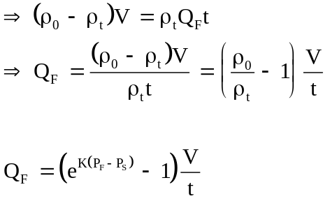

Gas and Vapor Services
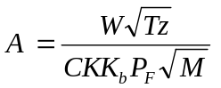
M = Molecular weitht
C is a function of 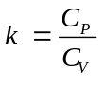
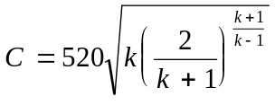
K = manufacturer coeficient (range about 0.95-1.0)
K_{b} = backpressure sizing factor
P_{b}/P_{s} | K_{b}
0.55 | 1
0.6 | 0.995
0.7 | 0.945
0.8 | 0.845
The above formula corresponds to the maximum possible velocity through an orifice : the velocity of sound in the fluid and is borrowed from compressible gas flow theory.
LETDOWN VALVES
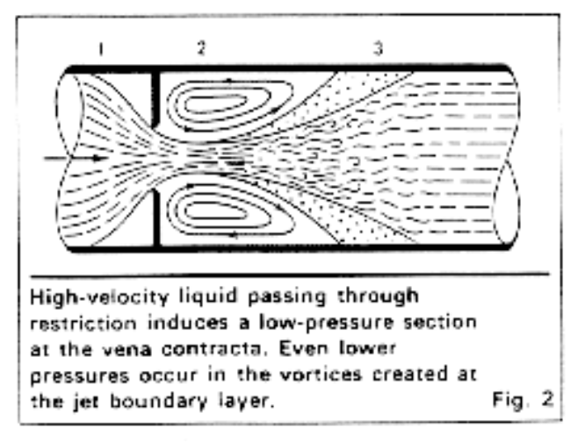
Gas letdown
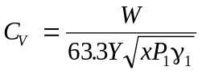
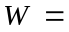flow rate
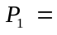inlet pressure (psia)
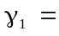density (lb/ft³)
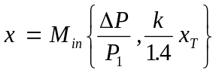
high ΔP will cause choke flow

Liquid letdown (Vaporization wil cause choke flow)
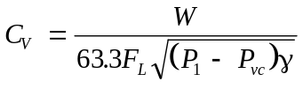
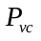= pressure at vena-contracta
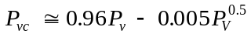
high ΔP will cause choke flow
F_{L} = Manufacturer constant (0.8-1.0)

