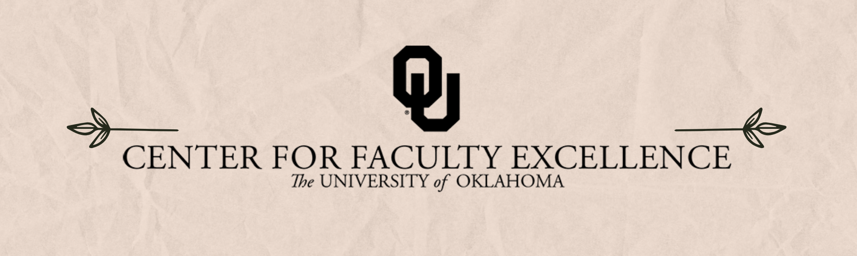

February 2025 ISSUE 2

Calendar | Phone | Email
https://calendar.ou.edu/cfe/all | 405-325-2323 | cfe@ou.edu

Dear Faculty,
As we close out the first month of 2025, I encourage you to engage with your colleagues across campus in one of our writing groups, cohorts, or learning communities. These groups not only help you build connections and network, they can also help strengthen a sense of belonging and community—two attributes that are linked to improved mental health. Upcoming groups include Teaching Squares, Befriending the Bot, and the NSF CAREER proposal cohort. We also welcome you to join us for caffeine and conversation every Tuesday, Wednesday, and Thursday from 8-10am in OSH- we’d love to chat with you about your grading woes or your next project idea!
I also encourage you to join OU Elevate’s Faculty Workload Study ($!) as well as the upcoming Teach OUt on Race and the Fulbright Fellowship info sessions. You can find more details about these and other upcoming opportunities at the end of this message in the Non CFE Events/Opportunities section.
As always, we also have several workshops in February to support your teaching, research and creative activity, and writing goals, including a special Gradescope workshop to help you overcome those grading woes. If you have any questions or would like additional support, please email cfe@ou.edu or submit a CFE Support Request Form.
Best wishes,
Megan Elwood Madden on behalf of the CFE Team
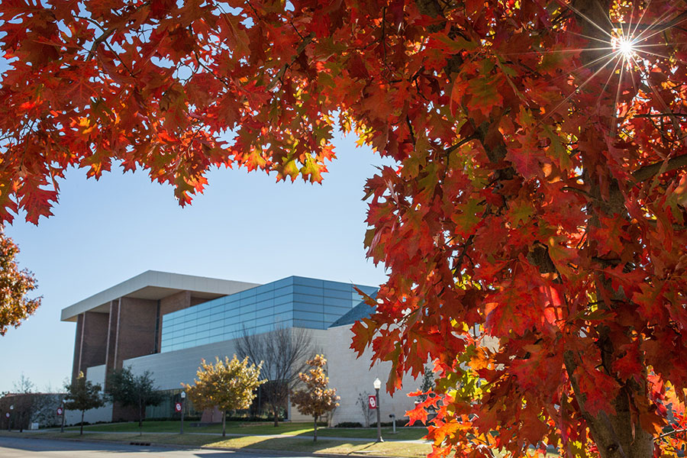
February 2025 CFE Events
Faculty Career Progression and Well-Being
February 1, 2025, 9:00 AM – 12:00 PM
Tenure and Promotion Workshop – Preparing your Dossier (4th-5th year)
This workshop will provide an overview of the specific steps in the tenure and promotion process, the contents of the dossier and information about recommending external reviewers. In addition, recently tenured faculty from the STEM, social sciences, professional programs, humanities, and fine arts will meet with faculty from these respective disciplines to answer any additional questions about the process and experience. This workshop is open to all Assistant Professors at OU who plan to submit their dossiers within the next 2 years. This is a hybrid workshop- we strongly encourage in person attendance but will provide Zoom access for those unable to attend in person.
February 8, 2025, 9:00 AM – 12:00 PM
Promotion to Full Workshop– Preparing your Dossier
This workshop will provide an overview of the steps in the promotion process, the contents of the dossier and information about recommending external reviewers. In addition, recently promoted faculty from the STEM, social sciences, professional programs, humanities, and fine arts will meet with faculty from these respective disciplines to answer any additional questions you might have about the process and experience. This workshop is open to all Associate Professors at OU Norman, it is most useful for those who plan to submit their dossiers within the next 1-2 years. This is a hybrid workshop- we strongly encourage in person attendance but will provide Zoom access for those unable to attend in person.

Research & Creative Activities
Wednesdays, Spring 2025, 2:00 PM – 4:00 PM

Digital Humanities Research Support
Sam Huskey, Senior Faculty Fellow in Digital Humanities, will hold Digital Humanities office hours on Wednesdays from 2:00 to 4:00 p.m. in the Studio Meeting Space C on Lower Level 1 in Bizzell Library. Please drop by to talk about your project, to get help with technical problems, or just to have a place to work on DH research. For more information: huskey@ou.edu.
February 3, 2025, 1:00 PM – 2:30 PM

Info Session with National Humanities Center (NHC) Program Officer
During this Zoom info session, Martha Kelly, Vice President for Scholarly Programs at the National Humanities Center (NHC) will provide an overview of the Fellowship and Summer Residency Programs at the NHC, in North Carolina. She will describe the application and review process and be available to answer faculty questions about the fellowship, residency, and applications. OU faculty who have been Fellows and Summer Residents at the NHC will also be on the Zoom call to answer questions and discuss their experience. This workshop is open to all faculty at OU in the humanities and interpretive social sciences.
February 14, 2025, 11:00 AM – 2:00 PM
Join the Digital Humanities Community of Practice and University Libraries to celebrate Douglass Day!
Douglass Day is an annual program sponsored by the Library of Congress that marks the birth of Frederick Douglass. Although Douglass never knew his birthdate, he chose to celebrate every year on February 14th. Each year, thousands of people gather to help create new & freely available resources for learning about history.
This event will include:
- A livestream from the national Douglass Day initiative.
- A transcribe-a-thon featuring the African American Perspectives Collection at the Library of Congress.
  - What is a transcribe-a-thon? Transcribe-a-thons are events in which people gather together to work side-by-side on a crowdsourcing transcription project. Bring a laptop with internet access to participate. A limited number of laptops will also be available for participants to use.
- A cake bake-off! If you choose to participate in the bake-off, please bring it to share as we transcribe!
All are welcome to attend!
February 20 to March 13, 2025, 10:00 AM – 11:30 AM
NSF CAREER Proposal Development Series
Four workshops held weekly from Thursday, (in-person)
The Research & Creative Activities team will host four weekly sessions. Sessions include:
Session 1: Framing your problem, aligning with an NSF program, community engagement.
Session 2: Structuring proposed work and setting the stage.
Session 3: Developing and integrating your education plan.
Session 4: Developing your research method and tasks.
Participants will also be encouraged to participate in a Peer Review exercise.

Teaching

Consultations on Preparing Annual Review for Teaching

As you take a moment to reflect on your teaching for your annual review and development, Dr. Hong Lin is available to work with you on self-reflection of your teaching, student feedback, areas for growth, teaching statement, and setting goals for future professional development.
Biweekly, Wednesdays, 11:00 AM – 11:50 AM, January 29 through April 23, 2025
Befriending the Bot without Losing Your Humanity: A Learning Community for AI Usage Options
You’re invited to join this learning community where we will collectively explore potential use cases of Generative AI in your course design, hosted by CFE’s teaching team and facilitated with Dr. Rebecca Huskey. Dr. Huskey is one of the Arts & Humanities Forum’s public fellows for 2024-2025. During each meeting, we’ll experience a brief guided activity, followed by open discussion on the usefulness of using Generative AI, how to assess the output for appropriateness and accuracy, ethics of Generative AI use, and more. Topics to be discussed include:
- How to learn and teach about Generative AI
- Using Generative AI to improve your syllabus
- Designing creative assessments with Generative AI
- Generating PowerPoints and lecture notes
- TopHat’s Generative AI features
- Improving accessibility with Generative AI
February 7, 2025
Teaching Squares Registration
Join us for the Spring’s semester’s cohort of the Teaching Squares Program at OU facilitated by Dr. Erin Freeman! This is an opportunity to reflect upon and enhance your teaching while learning from and growing with your colleagues. In this program, you will be paired with colleagues who represent a wide range of expertise and experience. Together, your "square" will engage in reciprocal classroom observations during the Fall semester. This peer observation is non-evaluative, supportive, and focused on the growth of all participants. At the end of the semester, all squares will gather for a celebratory discussion in which we will reflect on the various ways that observing our colleagues' teaching enriched our own teaching. Learn more about eligibility and time commitment at our Teaching Squares webpage. The location and time of our introductory meeting will be provided after registration closes. The initial meeting will take place during either the third or fourth week of February.
February 13, 2025, 3:00 PM – 4:00 PM
Benefiting from a Classroom Observation
Classroom observations allow you to document your teaching successes and hone your skills. We’ll discuss identifying shared goals and opportunities for growth, understanding the diversity of effective teaching practices, effective feedback through transparent communication, and how to develop an action plan. If you are interested in observing someone’s class, or having your course observed, this is the workshop for you!
February 19, 2025, 10:00 AM – 11:00 AM
Creating and Assessing Group Work
Want to assign group work because it’s a necessary skill for students to learn, but remember hating group work yourself? Or not sure how to assess group work fairly, or set students up for success? Group performance is often translated into individual grades, which raises issues of fairness, equity, and motivation. This workshop will discuss multiple ways to assess group work effectively and how to help students establish group guidelines.
February 21, 2025, 1:00 PM – 2:00 PM
Streamline Your Midterms with Gradescope: Faster, Easier Grading for Faculty in All Fields
Gradescope, available for free through OU’s enterprise license, facilitates grading approaches that cut down on grading time – for both online and paper-based assignments. Join instructors from Economics, Computer Science, and Women’s and Gender Studies to discuss how they use Gradescope to grade more effectively and provide students with feedback. From writing to art to equations to computer code, Gradescope can assist instructors in all fields. Drs. Nghiem Huynh (Assistant Professor of Economics), Sanjana Mudduluru (Assistant Professor of Computer Science), and M. Geneva Murray (Sr. Associate Director of Teaching, CFE) will share the benefits of Gradescope before answering your questions about how you can use Gradescope in your courses.

Non-CFE Events/Opportunities
February 7 and February 21, 2025
Oklahoma Learning Innovation Summit
Please join us for our next OKLIS Virtual Sessions in February! We will have TWO events on Preparing for the ADA Compliance Deadline, one focusing on faculty needs (February 7th) and the other on staff needs (February 21st). Anyone is welcome to attend either or both regardless of the intended audience.
Did you know that ADA Title II requires higher education to be compliant with WCAG 2.1 AA Standards by April 24, 2026? These sessions are designed to help all of us in Oklahoma higher education improve our ability to serve our students and communities through improved accessibility.
All who register will receive the recordings and resources for the registered session(s). Participants (synchronous or asynchronous) will have the opportunity to complete an assessment and earn an OKLIS Professional Development badge issued by OSRHE.
Please share this information with your colleagues!
February 21, 2025, 9:00 AM to 1:30 PM
Career Everywhere Symposium
in the Jim Thorpe Multicultural Center (1620 Asp Ave, Norman, OK 73019)
Has a student ever asked you for help with the job search? Do you work with students who are interested in careers overseas? Would you like to learn about how to integrate career resources into your curriculum? Save the date and join the Career Center & fellow faculty and staff to gain expertise on supporting the career readiness of your students through interactive discussions, an overview of digital resources, an employer panel, and more!
Friday, February 21, 2025
Teach OUt On Race
Teach OUt is an opportunity for students, staff, and faculty to intentionally consider how we teach, learn, and lead.
Compensated Study: OU Elevate Examination of Faculty Workload
The OU Elevate (NSF ADVANCE) project requests your participation in a study to better understand factors contributing to faculty time allocation and approaches to achieve teaching, research, or service workload objectives.
We invite tenured/tenure-track faculty members at OU to share your experiences to improve understanding of the challenges that faculty experience. You will be asked to complete two brief online surveys and track your daily work activities for two weeks using a time-tracking software platform. We recognize that this is an additional demand for your limited time, and in recognition of this, offer compensation via supplemental pay up to $400 dependent on study activity completion.
February 24 (3:00 PM) and February 26 (12:30 PM)
Fulbright U.S. Scholar Program
Join us for one of two information sessions on the Fulbright U.S. Scholar Program at DFCAS on February 24th (3pm) and February 26th (12:30 pm) in 323 Ellison Hall.
During these sessions, previous awardees will discuss the program and answer your questions. They will share insights and tips on the application process based on their experiences in various countries. These two sessions are independent in terms of content and scheduled at different times for your convenience.
DCFAS Faculty Symposium
The Dodge Family College of Arts and Sciences is pleased to continue its support for excellence in research and creative activity through Junior Faculty Summer Fellowships (JFSF), Senior Faculty Summer Fellowships (SFSF), Collaborative Research Faculty Fellowships (CRFF) and a program to support Data Scholarship Initiatives and Research Collaborations (DSIRC). To learn more about what has been funded through these programs this past year come to our Research Fellow Symposium this Wednesday March 5th, from 3:00pm to 4:30pm in the Dale Hall Tower community room, 906.

