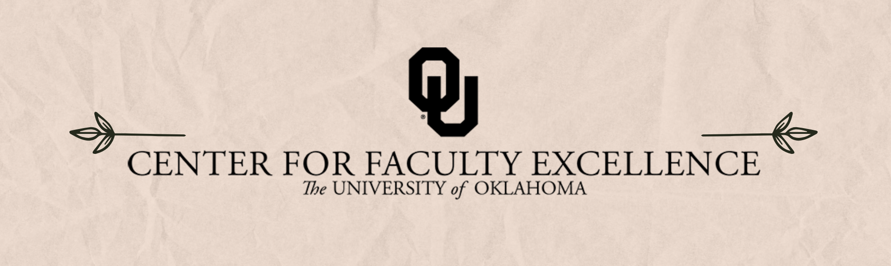

January 2025 ISSUE 1

Calendar | Phone | Email
https://calendar.ou.edu/cfe/all | 405-325-2323 | cfe@ou.edu

Dear Faculty,

Happy New Year! As we enter 2025, The Center for Faculty Excellence has many teaching-focused events planned January 6th-9th to help you prepare for your spring semester courses. In addition, we will also be offering 3 different workshops in our Tenure and Promotion series on Saturdays Jan. 25th, February 1st, and Feb. 8th. You can find more details and registration links for these timely workshop offerings in the descriptions below!
With the new year, we are also excited to welcome two new Senior Faculty Fellows to our team— Dr. Wayne Riggs (Philosophy) and Dr. Sandra Tarabochia (English) will be working with faculty writers, partially filling the Faculty Writing Coach role through 2025. Wayne will provide feedback on documents associated with tenure and/or promotion, along with general coaching for faculty focused on career progression, while Sandy will provide feedback and coaching to support faculty’s scholarly writing, including journal articles, book chapters, monographs, and book proposals. Please submit CFE’s support request form or email cfe@ou.edu to request a consultation or document review.
We are also re-organizing our faculty writing groups for the spring semester:
Dr. Sarah Tracy will lead the Monday Writers group on Zoom from 10am-noon
Dr. Robert Scafe will facilitate the in-person Proposal Writer’s Coffee Hour on Tuesdays, 8am-10am in Old Science Hall Room 223.
Dr. Tarabochia will lead the Wednesday Faculty Writers group from 9 am- 11 am on Zoom
Dr. Ladan Mozaffarian will lead the Lunchtime Inkspiration writing group that meets via Zoom on Wednesdays from 12-1
Dr. Riggs will lead the Rise and Write group Thursdays from 8-9am on Zoom
If you are interested in joining one or more these writing groups, please email cfe@ou.edu or the writing group leader directly.
As always, we welcome your feedback and suggestions to strengthen the resources we provide for faculty. If you received an email requesting feedback on a CFE consultation (12/12/24), please take a few minutes to respond. If you did not receive the survey but would like to provide feedback on based on your experience with CFE consultations, please email cfe@ou.edu and we will send you the link!
Best wishes,
Megan Elwood Madden on behalf of the CFE Team
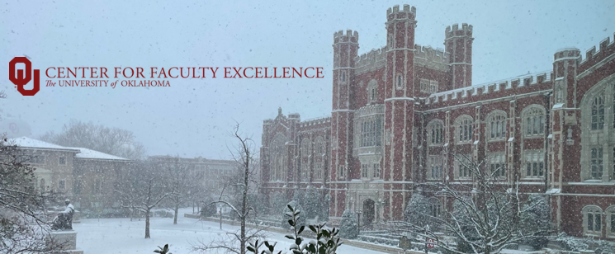
January 2025 CFE Events
Faculty Career Progression and Well-Being
Saturday, January 25, 2025, 9:00 AM – 12:00 PM
Tenure and Promotion Workshop – The First 3 Years
This hybrid workshop will provide an overview of the steps in the tenure and promotion process, the contents of the dossier, and tips to help you prepare while navigating the first few years in your faculty role. This workshop is open to all Assistant Professors within their first few years at OU. This workshop will be held on the OU Norman Campus, with Zoom access for those who cannot attend in person. A light lunch will be provided.

Saturday, February 1, 2025, 9:00 AM – 12:00 PM
Tenure and Promotion Workshop – Preparing your Dossier (4th-5th year)
This workshop will provide an overview of the specific steps in the tenure and promotion process, the contents of the dossier and information about recommending external reviewers. In addition, recently tenured faculty from the STEM, social sciences, professional programs, humanities, and fine arts will meet with faculty from these respective disciplines to answer any additional questions about the process and experience. This workshop is open to all Assistant Professors at OU who plan to submit their dossiers within the next 2 years. This is a hybrid workshop- we strongly encourage in person attendance but will provide Zoom access for those unable to attend in person.
Saturday, February 8, 2025, 9:00 AM – 12:00 PM
Promotion to Full Workshop– Preparing your Dossier
This workshop will provide an overview of the steps in the promotion process, the contents of the dossier and information about recommending external reviewers. In addition, recently promoted faculty from the STEM, social sciences, professional programs, humanities, and fine arts will meet with faculty from these respective disciplines to answer any additional questions you might have about the process and experience. This workshop is open to all Associate Professors at OU Norman, it is most useful for those who plan to submit their dossiers within the next 1-2 years. This is a hybrid workshop- we strongly encourage in person attendance, but will provide Zoom access for those unable to attend in person.

Research & Creative Activities
Wednesdays, Spring 2025, 2:00 PM – 4:00 PM

Digital Humanities Research Support
Sam Huskey, Senior Faculty Fellow in Digital Humanities, will hold Digital Humanities office hours on Wednesdays from 2:00 to 4:00 p.m. in the Studio Meeting Space C on Lower Level 1 in Bizzell Library. Please drop by to talk about your project, to get help with technical problems, or just to have a place to work on DH research. For more information: huskey@ou.edu.

Teaching

Consultations on Teaching Preparedness

As you are coming back to the new semester, January is the perfect time to reach out to Dr. Hong Lin for a consultation on your teaching. Whether your goal is to develop or revisit a syllabus, review student reflection feedback, (re)design an assignment, or finalize a rubric, among others, she can help you meet your goals. Schedule your one-on-one Zoom consultation by booking a consultation with Dr. Hong Lin.
Monday, January 6, 2025, 10:00 AM – 11:30 AM
(Re)Designing Your Course: Course Design Using Backward Design
(Re)Design your course in a supportive, structured, and communal environment. Using a backward design approach, this workshop provides opportunity for you to work on your course (re)design by engaging in reflective activities to consider what, when, and how the course will be taught, as well as how the course objectives are achieved.

Monday, January 6, 2025, 1:00 PM – 2:00 PM
Motivate Your Students from Day One: Syllabus Design
A key component to student success is a sense of belonging in the classroom and at the university. This workshop provides participants with strategies to build rapport with students so that they feel more connected with you and their peers. Participants are encouraged to bring their own ideas, while also learning about Student Background and Experience surveys, icebreakers, establishing community expectations, and motivational language.
Tuesday, January 7, 2025, 10:00 AM – 11:30 AM
Facilitating Group Discussion
Led by Dr. Julie-Françoise Tolliver, this workshop includes tips for effective facilitation of group discussions. Many discussion-based classrooms quickly devolve into a dynamic of instructor-student Q and A, with a small percentage of students accounting for most of the participation. It doesn’t have to be this way. Drawing on Stephen Brookfield’s Discussion as a Way of Teaching, this workshop will show you how to coach student-to-student interactions, set expectations for participation from day one, and anticipate “flare ups” with proactive discussion guidelines. We will also learn how to leverage the discussion dynamic to model academic skills such as citation, collaboration, and problem solving.
Tuesday, January 7, 2025, 1:00 PM – 2:30 PM
You Belong Here: Building Rapport with Students to Improve Academic Outcomes
A key component to student success is a sense of belonging in the classroom and at the university. This workshop provides participants with strategies to build rapport with students so that they feel more connected with you and their peers. Participants are encouraged to bring their own ideas, while also learning about Student Background and Experience surveys, icebreakers, establishing community expectations, and motivational language.
Wednesday, January 8, 2025, 10:00 AM – 11:30 AM
Organizing Your Course Using Canvas: Pedagogical Approaches
Canvas can be used strategically as a pedagogical tool to build community, help students make connections between course topics, and much more. We’ll discuss how to organize information using modules, making information easier for your students to find, as well as some of the external tools that can help make your Canvas a site for engagement and learning. This is a hybrid event: online via Zoom, in-person on the Norman campus.
Wednesday, January 8, 2025, 12:00 PM – 4:30 PM
Collaborative Workspace with CFE and OU IT Learning Spaces: Canvas, Syllabi, and Course Design
Bring your Canvas questions to this open workspace. Both Mika Cox from OU It Learning Spaces and the teaching team from CFE will be available to help with your Canvas questions. You may also bring syllabi or course design questions to the CFE’s teaching team.
Registration Due Monday, January 27, 2025, 8:00 AM
Inclusive STEM Teaching Learning Community
The learning community will meet weekly on Tuesdays, from 1:30 p.m. – 2:30 p.m. beginning January 28th through March 11th.
Interested in inclusive teaching practices that retain students in STEM? Join our Inclusive STEM Teaching Learning Community! In addition to participating in weekly meetings with OU participants, you’ll have access to the Inclusive STEM Teaching MOOC, an NSF funded project with an interest in student academic outcomes and retention in STEM. Our discussions will be grounded in the evidence-informed practices introduced in the MOOC. While beneficial to all STEM faculty, the discussions will be transferable to many disciplines. We welcome all OU instructors as participants! This learning community is not currently open to graduate students. This event is in-person on the Norman campus.
Biweekly, Wednesday’s 11:00 AM – 11:50 AM, January 29 through April 23, 2025
Befriending the Bot without Losing Your Humanity: A Learning Community for AI Usage Options
You’re invited to join this learning community where we will collectively explore potential use cases of Generative AI in your course design, hosted by CFE’s teaching team and facilitated with Dr. Rebecca Huskey. Dr. Huskey is one of the Arts & Humanities Forum’s public fellows for 2024-2025. During each meeting, we’ll experience a brief guided activity, followed by open discussion on the usefulness of using Generative AI, how to assess the output for appropriateness and accuracy, ethics of Generative AI use, and more. Topics to be discussed include:
- How to learn and teach about Generative AI
- Using Generative AI to improve your syllabus
- Designing creative assessments with Generative AI
- Generating PowerPoints and lecture notes
- TopHat’s Generative AI features
- Improving accessibility with Generative AI
Thursday, January 30, 2025, 12:00 PM – 1:30 PM
How to Support Students Under High Stress
Inspired by trauma-informed teaching principles (Dr. Janice Carello), this workshop provides examples of how those principles can be actualized within your course. We’ll discuss policies, email responses, resources, and strategies within the classroom to support students so they can engage more in your course. While applicable to all courses, we’ll provide additional tools for sensitive subjects, while supporting professional development. At the end of this session, faculty will choose 1-2 techniques to begin using in their classrooms and with their students.

Non-CFE Events/Opportunities
January 9 and 10, 2025
Academic Technology Expo
The OU Academic Technology Expo (ATE) is a collaborative event to enhance interdisciplinary technology use and effectiveness at the University of Oklahoma, both inside and outside the classroom.
Mark your calendars for January 9th & 10th, 2025! There will be a half-day of virtual presentations on January 9th and a full-day, in-person Expo on the Norman campus on January 10th. This day features in-person sessions, some of which will be streamed, and all will be recorded for later viewing.
While the focus of ATE 2025 is to showcase how faculty use Artificial Intelligence tools in their classes and the future of Al at OU, there will be a variety of topics surrounding academic technology.

