CFE | DJI MINI MICROPHONE CONNECTION GUIDE
Connect the DJI wireless microphone to the CFE Lightboard PC before opening eGlass Fusion.
1. TURN ON THE MICROPHONE
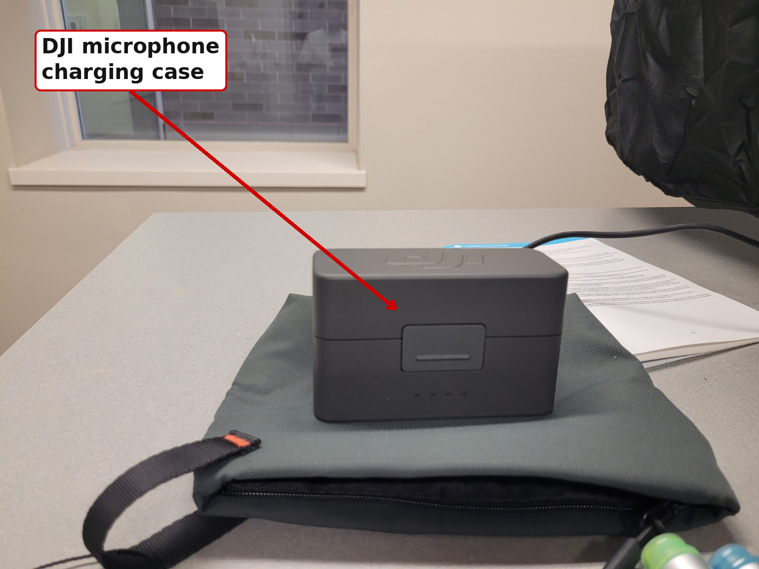 | Open the DJI charging case, remove the microphone, and press the Power button to turn it on.
2. PAIR THE MICROPHONE WITH THE LIGHTBOARD PC
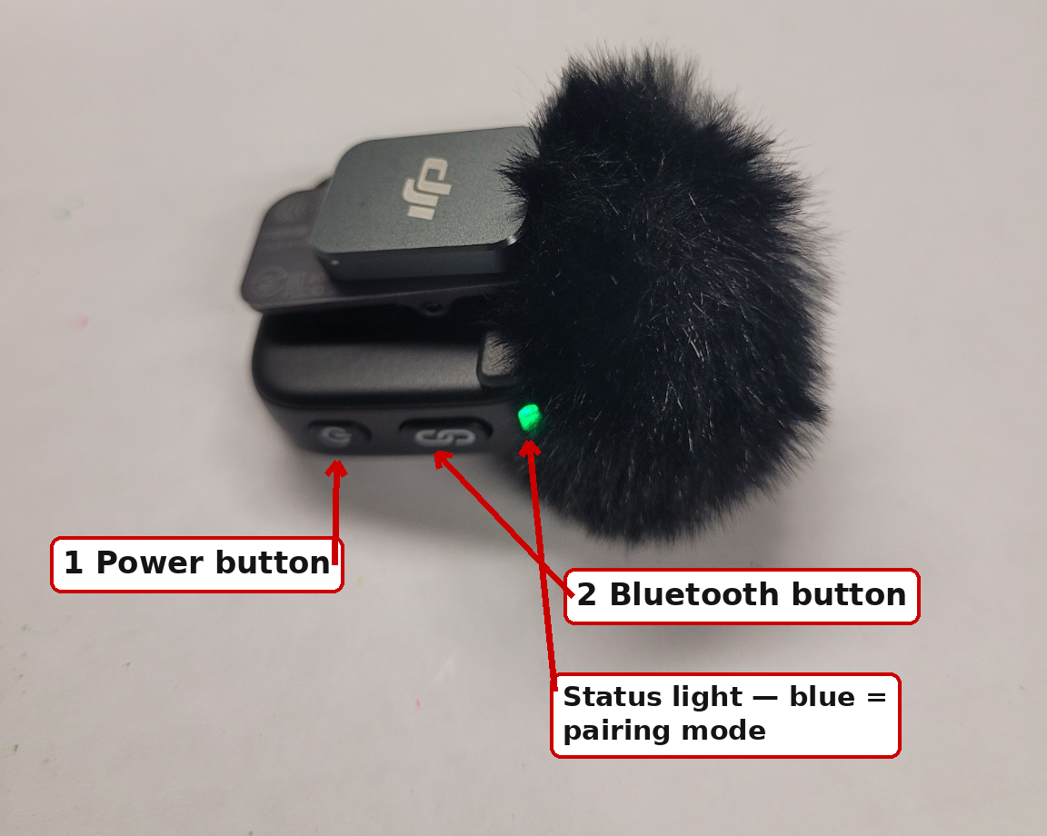 | A. Put the microphone in pairing mode  Press and hold the Bluetooth button until the status light turns blue.  B. Connect in Windows  - Open Settings > Bluetooth & devices.  - Choose Add device > Bluetooth.  - Select the DJI microphone when it appears.
3. SELECT THE DJI MICROPHONE IN EGLASS
- Open eGlass Fusion, go to Settings, and select the DJI microphone as the microphone/audio input.
If eGlass is already open and you do not see the DJI option, close eGlass and open it again.
4. TEST BEFORE RECORDING
- Record a short test video and play it back to confirm the microphone is working.
- When finished, turn off the microphone and return it to the charging case.

CFE Lightboard Room

