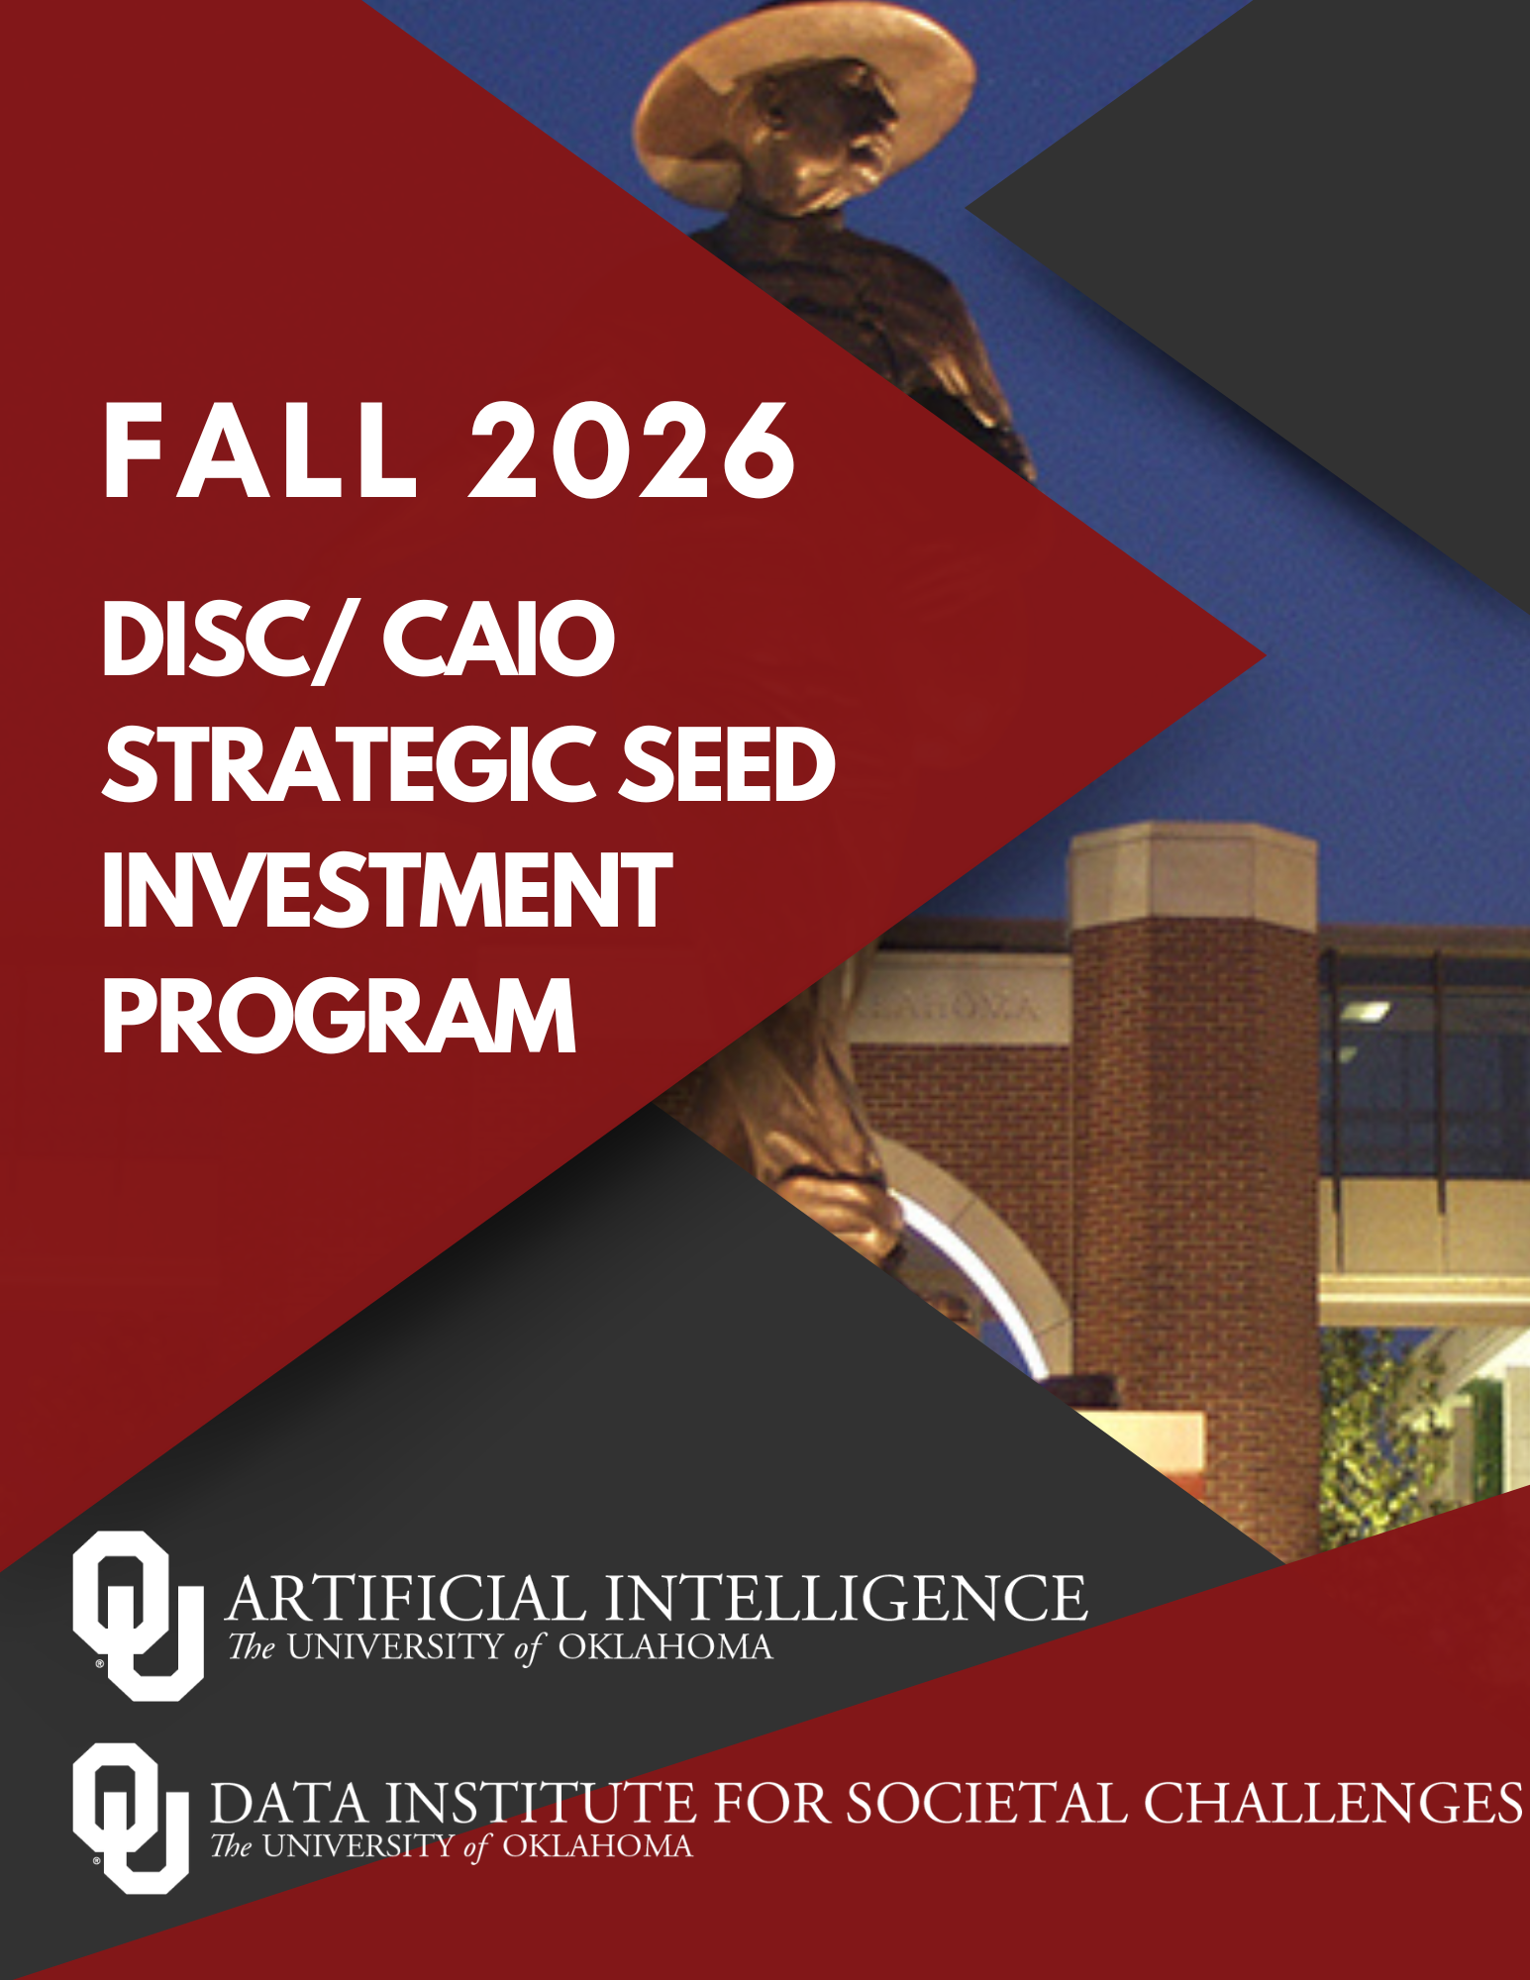

DISC/CAIO Fall 2026 Strategic Seed Investment Program
The Data Institute for Societal Challenges (DISC), in partnership with the Office of the Chief Artificial Intelligence Officer (CAIO), invites proposals for its Fall 2026 Strategic Seed Investment Program. Through this program, DISC and CAIO invest in interdisciplinary research teams that leverage artificial intelligence (AI), data science, and advanced analytics to address complex societal challenges while positioning the University of Oklahoma for future research growth.

These awards are intended to serve as strategic investments that accelerate innovative research, establish new collaborations, generate pilot results, and lead to measurable downstream outcomes, including competitive external funding, industry partnerships, technology development, and broader societal impact.

Please review the full solicitation for detailed application requirements and evaluation criteria.

Purpose
The Faculty Nexus Awards support interdisciplinary research teams pursuing ambitious, AI-enabled research aligned with the University of Oklahoma's strategic research priorities.
Projects should demonstrate strong potential to:

- Develop competitive proposals for major external sponsors
- Generate transformative pilot data
- Build sustainable interdisciplinary collaborations
- Advance human-centered, socially responsible approaches to AI-enabled research and innovation
- Produce measurable scientific, economic, or societal return on investment

This program seeks projects that would be difficult to initiate without strategic seed funding and that have clear potential for continued growth beyond the award period.

Award Details
- Award Amount: Up to $25,000 per project
- Number of Awards: To be determined based on available funding.
- Funding Period: 12 months

Eligibility
Applicants must satisfy all of the following requirements:
- Open to faculty from OU Norman, OU Health, and OU Tulsa.
- Teams must include a minimum of two faculty members from different academic departments engaged in an integrated research effort. Cross-campus collaborations among OU Norman, OU Health, and OU Tulsa are strongly encouraged.
- Teams must designate specific leadership roles:
  - An AI Lead: A researcher who advances algorithms, models, data pipelines, and evaluation strategies.
  - A Domain Research Lead: A researcher in the target application area who defines real-world problems, use-inspired domain challenges, datasets, success criteria, and deployment needs.
  - Note: While some members may bring both types of expertise, they can only fill one lead position.
- An individual may serve as Principal Investigator on only one proposal but may participate as a Co-PI on multiple proposals.
- All investigators must be DISC members.
  - DISC membership form:https://ousurvey.qualtrics.com/jfe/form/SV_6JAR3HMzwGifSDk

Priority Alignment
Proposals must align with one or more OU strategic research areas and address the major program goals.

OU Strategic Research Areas
- Health – Lifting the health of Oklahomans through AI, data science, and informatics; translational research and biomedical innovation; remote monitoring, digital health and access to care; and growing Oklahoma’s biotech and health workforce and technology development.
- Energy – Advancing Oklahoma’s innovation and leadership in energy via enabling sustainable, resilient, and secure energy systems through research and innovation in critical minerals, geothermal, oil & gas, industrial manufacturing, petrochemical, grid optimization, and energy policy.
- Extreme Weather – Advancing and improving prediction, mitigation, and resilience for severe weather hazards, leveraging the strengths of our weather enterprise, radar expertise, and AI/ML applications
- National Security & Defense – Strengthening security, readiness, and leadership through research in spectrum dominance, sustainment and modernization, autonomous and counter-autonomous systems, and alignment with state and national defense priorities.

Program Goals
- Support development of competitive external proposals (NIH, NSF, DOE, NOAA, DoD, DHS, ARPA-H, foundations, industry)
- Generate pilot data, prototypes, or feasibility studies
- Foster new and sustained interdisciplinary research teams
- Advance impact-driven research aligned with OU priorities

Application Requirements
Applicants must submit a proposal (maximum 5 pages, excluding references and budget).

- Challenge and Opportunity
Describe the societal or scientific challenge being addressed. Explain why solving this problem matters and why now is the appropriate time.

- AI and Data Science Innovation
Describe the proposed methodology. Explain how AI, machine learning, data science, advanced analytics, or computational approaches will be used to address the challenge. Explain why existing AI methods are not sufficient. Highlight the innovative aspects of the proposed work. (Note: Outline specific compute resource requirements, including local GPU/cluster needs or access for frontier models, etc. with specific benefits and purpose).

- Interdisciplinary Team
Describe the expertise of each investigator. Explain why the collaboration is essential for project success. Clearly define each team member's role.

- Data Assurance, IRB Requirements, and AI Compliance
Provide details on what data will be acquired/used/curated as appropriate. Detail plans on ensuring appropriate use of data and steps to be taken to assure that no restricted data is exposed to public AI models without authorization. Detail the status of IRB applications for human subjects research, and confirm alignment with OU's AI use compliance and data privacy guidelines.

- Strategic Alignment
Explain how the work aligns with OU Strategic Research Areas and DISC's mission.

- Pathway to External Investment
Identify targeted extramural funding opportunities, including the specific program and target deadlines if known.

Examples include:
- NIH
- NSF
- DOE
- DoD
- NOAA
- DHS
- ARPA-H
- Foundations
- Industry

Discuss how the proposed seed investment will strengthen the competitiveness of future submissions.

- Return on Investment (ROI) Strategy
DISC and CAIO view seed funding as a strategic investment. Describe the measurable outcomes expected within 12–28 months following project completion.

Applicants should identify at least two anticipated outcomes, such as:
- External proposal submissions
- External funding awards
- Industry partnerships
- Technology licensing
- Invention disclosures
- Patent applications
- Software or data products
- Clinical or operational implementation
- Community or Tribal partnerships
- Student and workforce development
- Other measurable impacts

Explain why DISC's and CAIO’s investment is expected to accelerate these outcomes.

- Project Timeline
Include a detailed timeline with specific milestones for the project.

- Budget and Justification
Provide a project budget (maximum $25,000) and concise justification.

Allowable Use of Funds
- Graduate or undergraduate research support
- Data acquisition, software, or computational resources
- Pilot experiments, fieldwork, or prototype development
- Community, Tribal, or industry engagement
- Supplies
- Faculty summer salaries
- Other reasonable project-related costs that directly support project activities and objectives

Resumes (Maximum 2 pages per team member)

Award Expectations
Awardees become members of the DISC Strategic Investment Portfolio and are expected to actively engage with DISC throughout the project period.
Awardees must:

- Attend a kickoff meeting.
- Participate in mentoring and research development activities.
- Submit a six-month progress report documenting progress toward proposed milestones.
- Present project outcomes at a DISC/CAIO research showcase or seminar.
- Submit a final project report.
- Submit at least one external proposal, industry-sponsored research proposal, commercialization disclosure, or equivalent follow-on opportunity within 12 months after project completion.
- Submit a 12-month impact report documenting outcomes resulting from the DISC/CAIO investment.
- To build a library of reusable AI/Data Science artifacts, each awarded team must deliver a tangible demonstration product suitable for public dissemination at the end of the funding period. The proposal must specify this product (e.g., a working prototype, method demonstration, documented tutorial notebook, technical report). Where applicable, this must include a reproducible run package (source code and environment manifest), a brief methodological write-up, and documentation.

Key Dates
- Proposal Deadline: Sunday, September 27, 2026 at 11:59 PM CT
- Submission: Please complete this online submission form and upload your proposal: DISC/CAIO 2026 Fall Seed Funding Opportunity – Fill out form
- Award Notification: Monday, November 16th

Evaluation Criteria
Proposals will be evaluated based on their scientific merit, strategic alignment, potential for future growth, and likelihood of generating measurable outcomes that extend beyond the initial DISC investment.

Evaluation Criterion | Points | What Reviewers Will Evaluate
Challenge & Opportunity | 15 | Reviewers will evaluate the significance of the societal or scientific challenge, the urgency and importance of addressing it, and the potential for the project to generate meaningful scientific, economic, or societal impact. Strong proposals clearly articulate why the problem matters and why now is the right time to pursue the work.
AI & Data Science Innovation | 20 | Reviewers will assess the originality, technical merit, and appropriateness of the proposed AI, machine learning, data science, advanced analytics, or computational approaches. They will evaluate whether AI is central to the project, how the proposed methods advance beyond existing approaches, and whether requested computational resources are well justified.
Interdisciplinary Team | 10 | Reviewers will evaluate whether the investigative team brings complementary expertise needed to accomplish the project. They will consider the strength of the collaboration, clearly defined leadership roles, meaningful integration across disciplines, and whether the partnership strengthens the likelihood of project success.
Data Assurance, IRB & AI Compliance | 10 | Reviewers will assess the quality of the project's data management strategy, including data acquisition, stewardship, privacy, security, and responsible AI practices. They will also evaluate plans for regulatory compliance, including IRB approvals (when applicable), protection of restricted or sensitive data, and adherence to University AI and data governance policies.
Strategic Alignment | 10 | Reviewers will evaluate how well the proposed project aligns with one or more of OU's Strategic Research Areas and advances the mission of DISC and the Office of the Chief AI Officer. Preference will be given to projects that clearly support institutional research priorities and demonstrate broad institutional value.
Pathway to External Investment | 15 | Reviewers will assess the strength and credibility of the team's strategy for pursuing external funding. They will evaluate whether specific funding opportunities, sponsors, and timelines have been identified and whether the proposed seed investment will substantially improve the competitiveness of future submissions.
Return on Investment (ROI) Strategy | 10 | Reviewers will evaluate the likelihood that the project will generate measurable outcomes beyond the initial award period. These may include competitive external proposals, funded awards, industry partnerships, technology commercialization, intellectual property, software or data products, workforce development, community partnerships, or other measurable impacts that demonstrate long-term value.
Project Timeline & Feasibility | 5 | Reviewers will evaluate whether the proposed timeline includes realistic milestones, measurable deliverables, and a feasible plan for completing the project within the 12-month funding period.
Budget & Justification | 5 | Reviewers will assess whether the requested budget is reasonable, cost-effective, and directly supports the proposed project activities. Budget requests should be well justified and aligned with the project's objectives and anticipated outcomes.
Total | 100

